- I used echo $0 to check which shell I am currently using. It displays the name of the active shell.
- I used the date command to check the current system date and time. It displays the date and time configured on my system.
- I used pwd to check my current working directory. It shows the complete path of the directory where I am currently working.

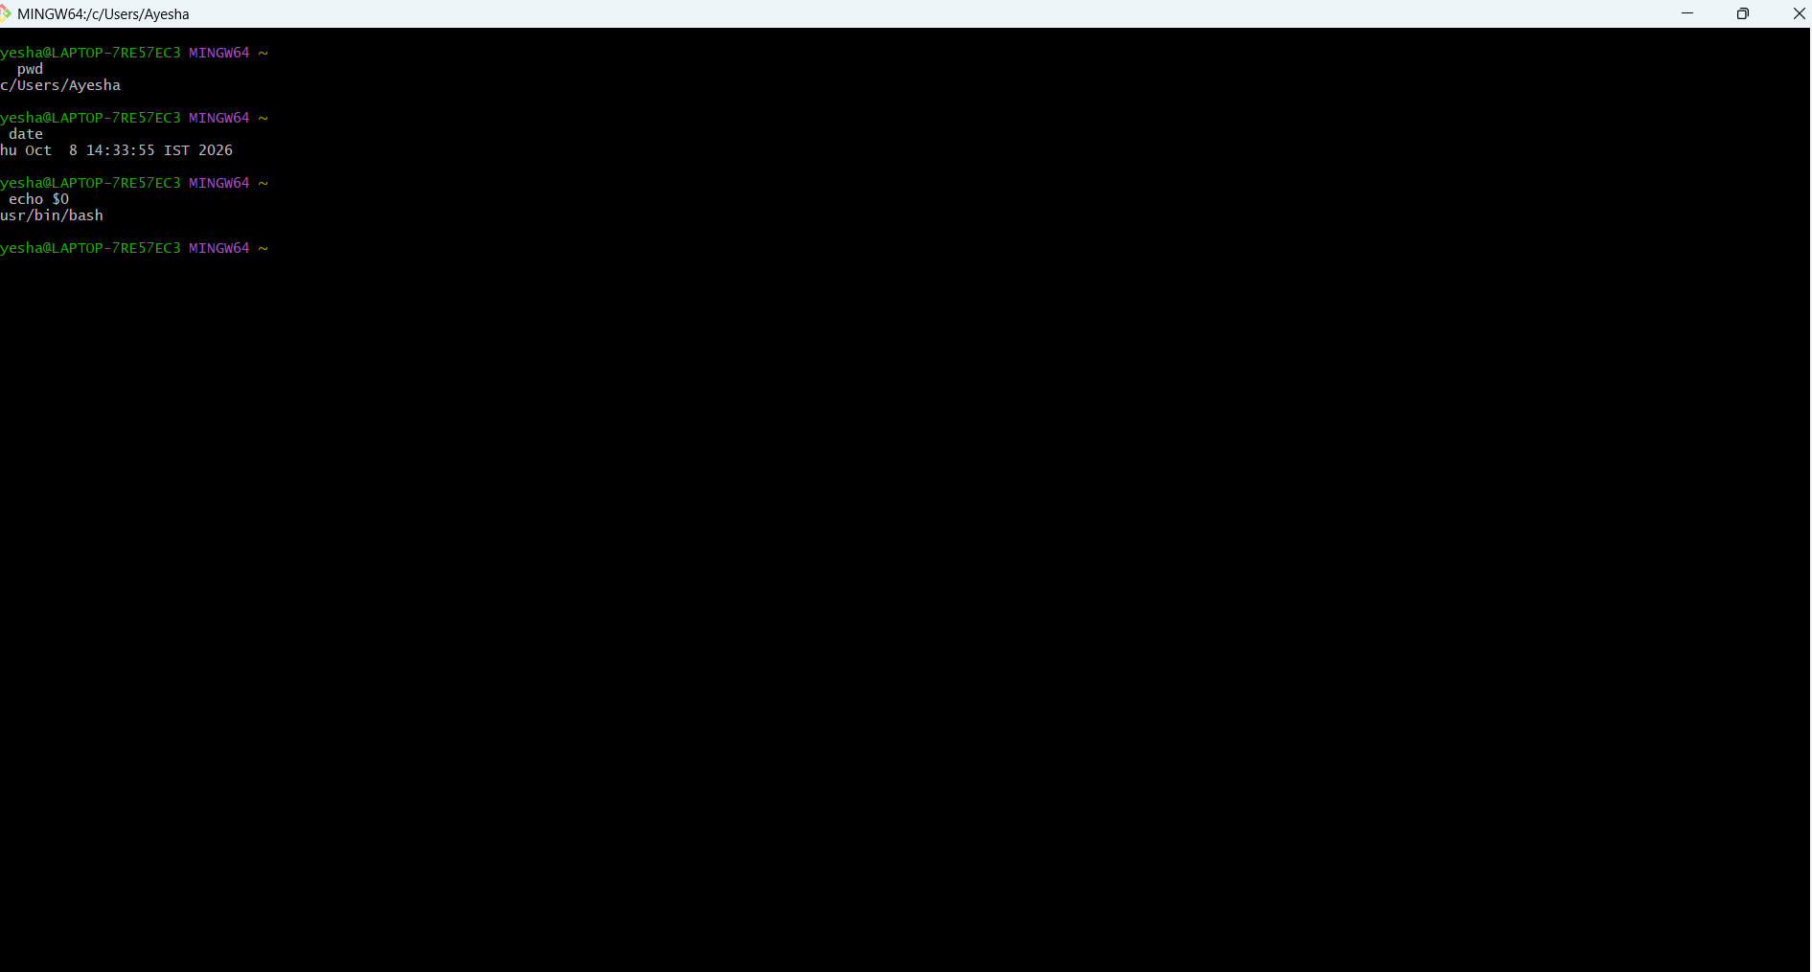

- I used ls to view the files and directories available in my current location. It helps me understand what is present in the directory.
- I used cd ~ to move to my home directory. It takes me directly to my user's home location
- I used cd Desktop/ to move from my current directory to the Desktop directory. This helps me navigate between directories.
- I used cd .. to move one level back to the parent directory. It helps me navigate to the previous directory level.

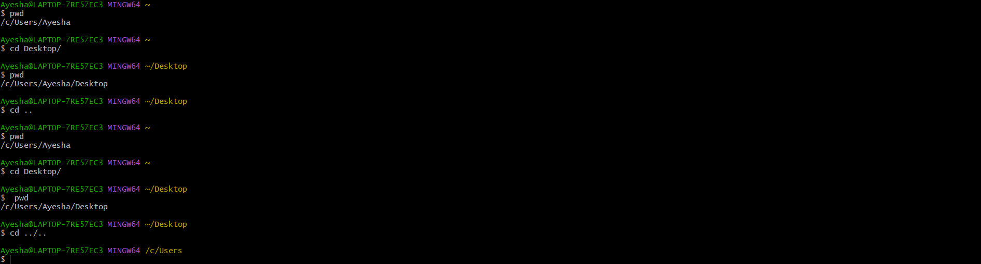

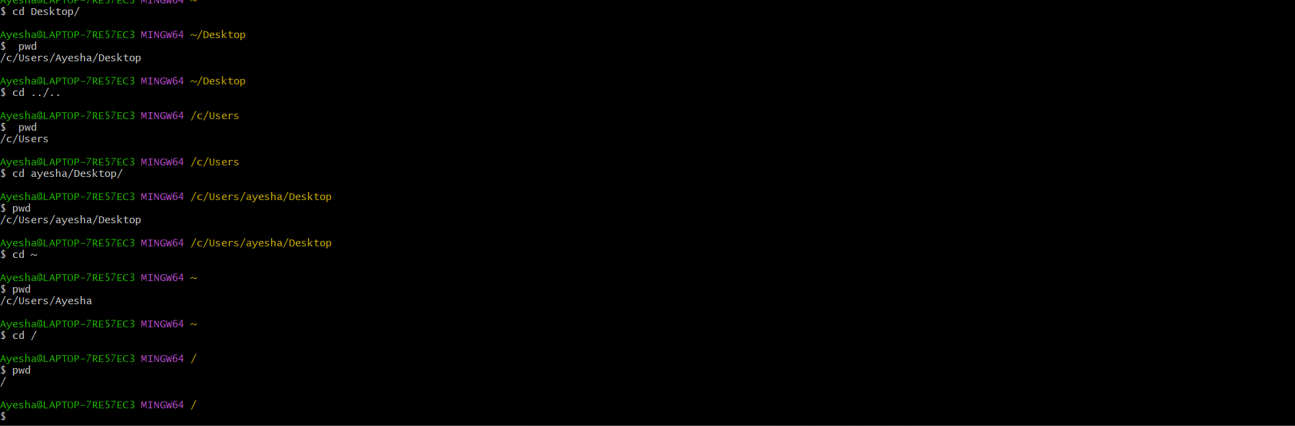

I used cd / to move to the root directory. The root directory is the top-level directory of the filesystem.
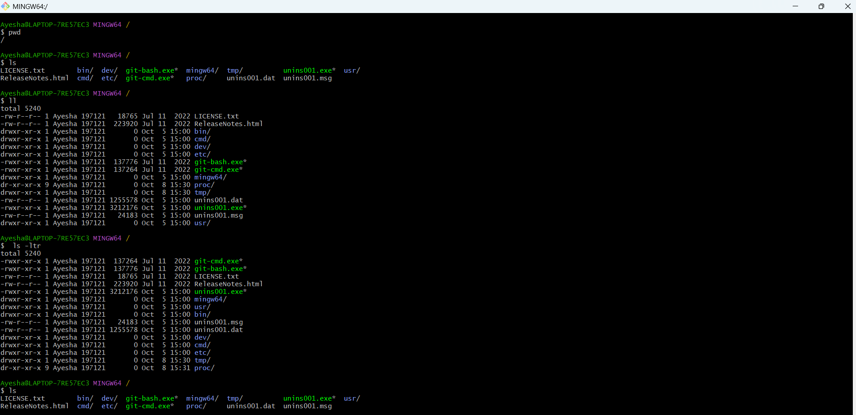
- I used clear to remove the previous output from my terminal screen. It makes the terminal clean and easier to work with.
- I used ll to view the files and directories in a detailed format. It displays information such as permissions, size, owner, and modification time.
- I used ls -ltr to list files in detailed format and sort them according to modification time. It helps me identify older and newer files.
- I used ls -a to display all files and directories, including hidden files. Hidden files usually start with a ..

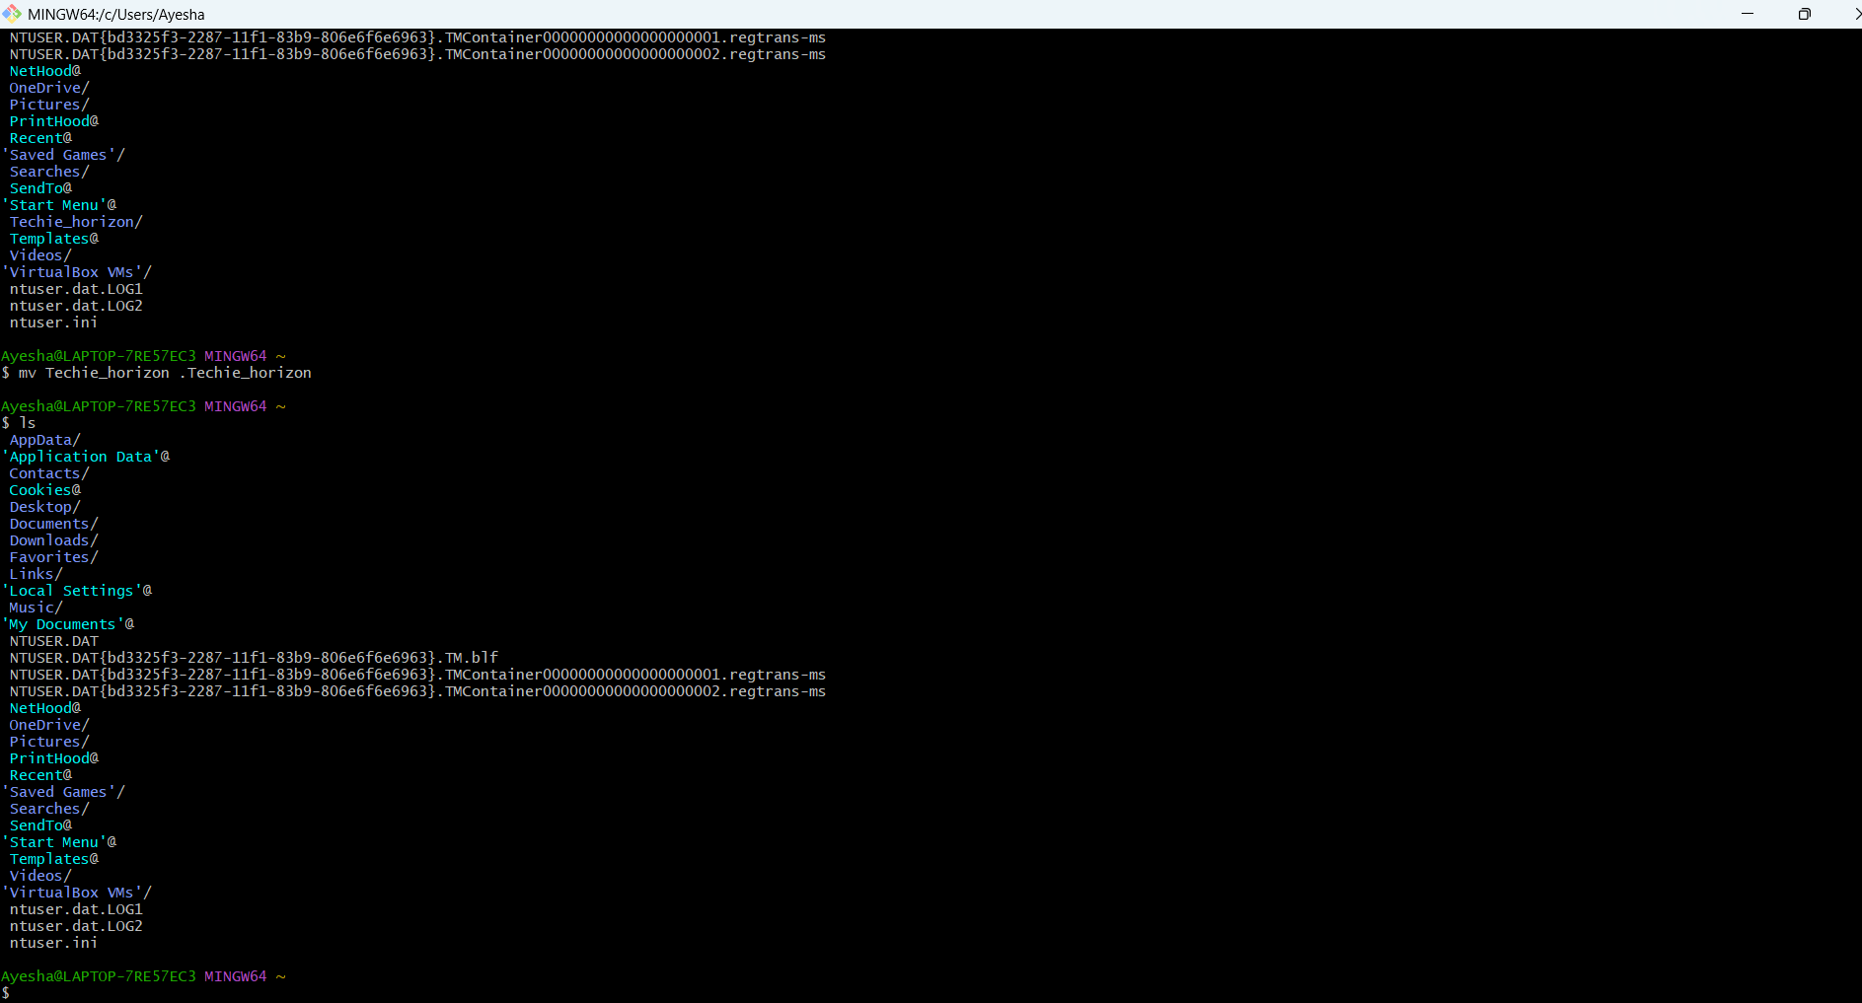

- I used mkdir Techie_horizon to create a new directory named Techie_horizon. This command is used to create directories.
- I used sudo mkdir Techie_horizon to create the directory with administrator privileges. sudo allows a command to be executed with elevated permissions.
- I used mv to rename the Techie_horizon directory to .Techie_horizon. By adding . at the beginning, I made the directory hidden.
- I used mv to rename the hidden .Techie_horizon directory back to Techie_horizon. This also makes the directory non-hidden.
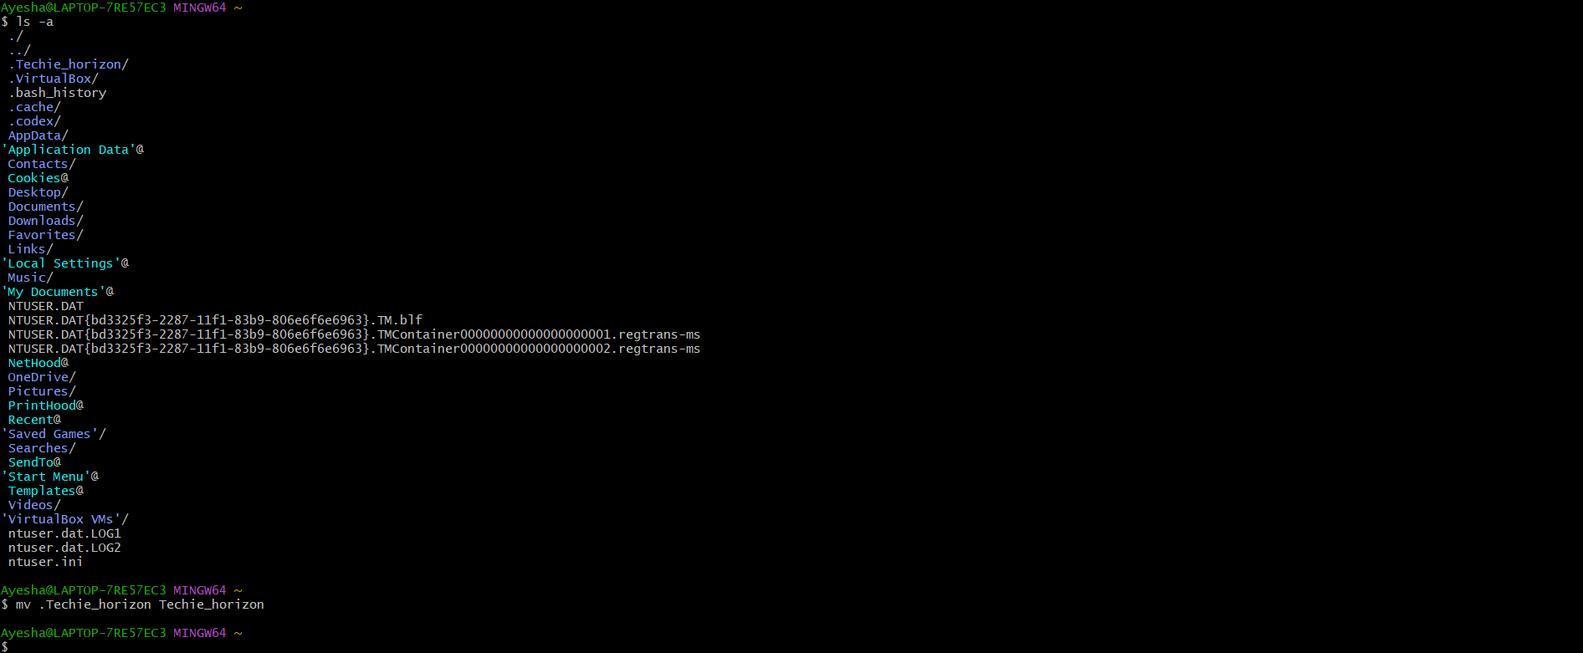

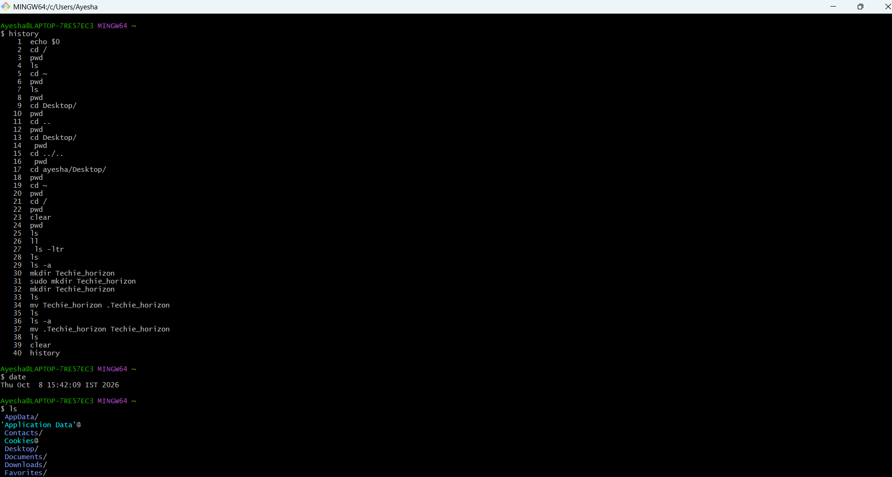

- I used the date command to check the current system date and time. It displays the date and time configured on my system.
- I used history to view all the commands I previously executed. It helps me keep track of the commands I performed during my task.
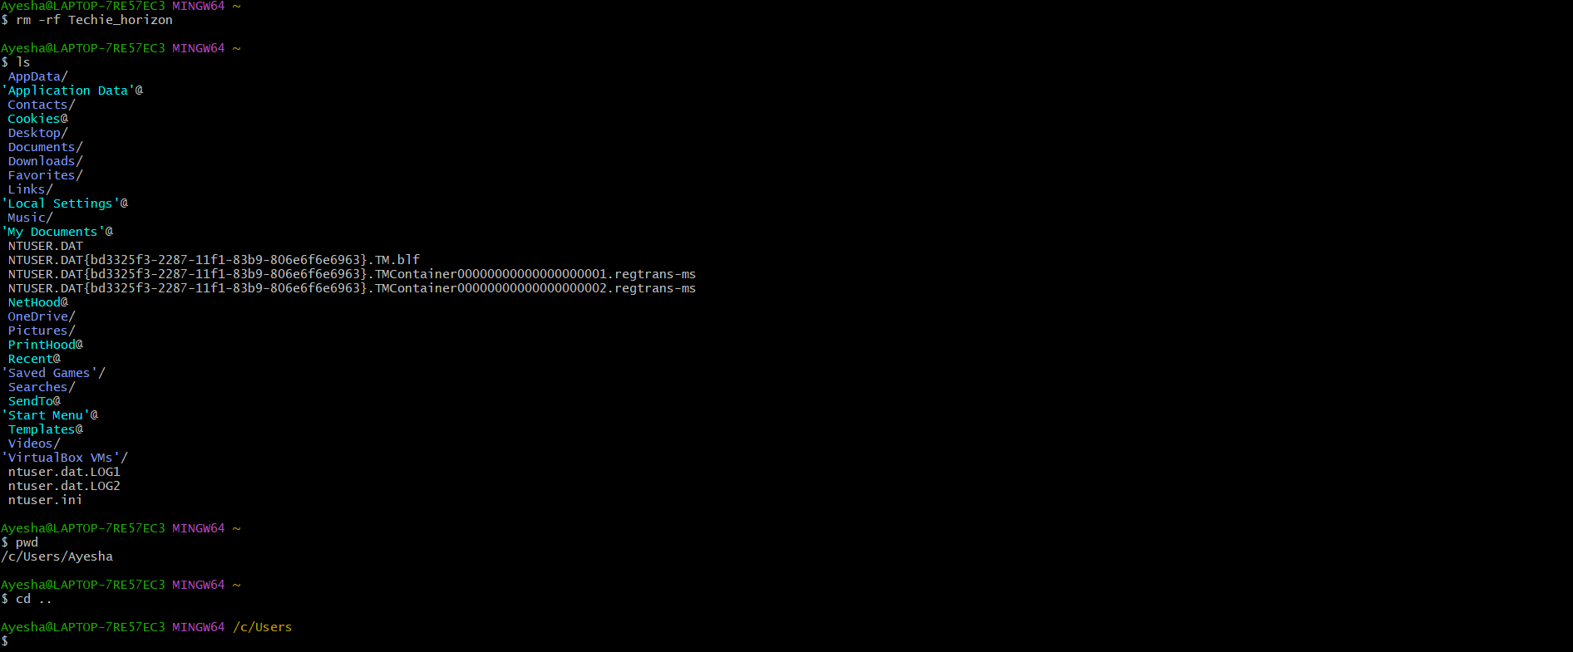

- I used rm -rf to remove the Techie_horizon directory. The -r removes directories recursively and -f forces the deletion without confirmation.
- I used mv to move the Techie_horizon directory from my current location to the Ayesha user directory. This command can also be used to rename files and directories.
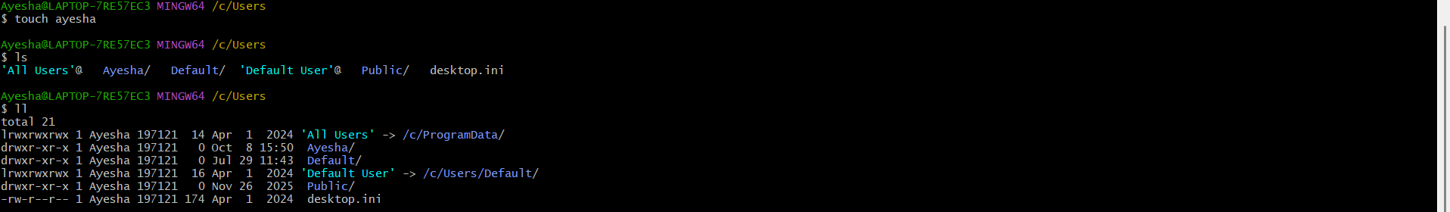
- I used touch ayesha to create an empty file named ayesha. The touch command is commonly used to create a new empty file.
- I used ll to check the files and directories in my current location in detailed format. It helped me verify the files I created.
- I used ls to check the files and directories available in my current location. It helped me verify what was present after my previous operations.
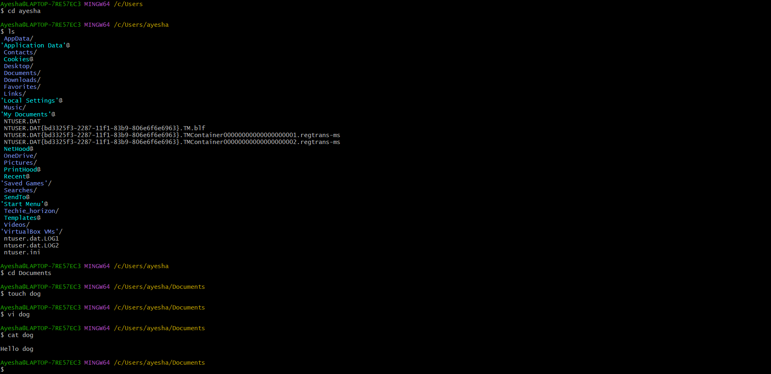

- I used touch dog to create an empty file named dog. I used this command to practice creating files.
- I used vi dog to open
- I used cat dog to display the contents of the dog file in the terminal. It helps me verify the content stored in the file.
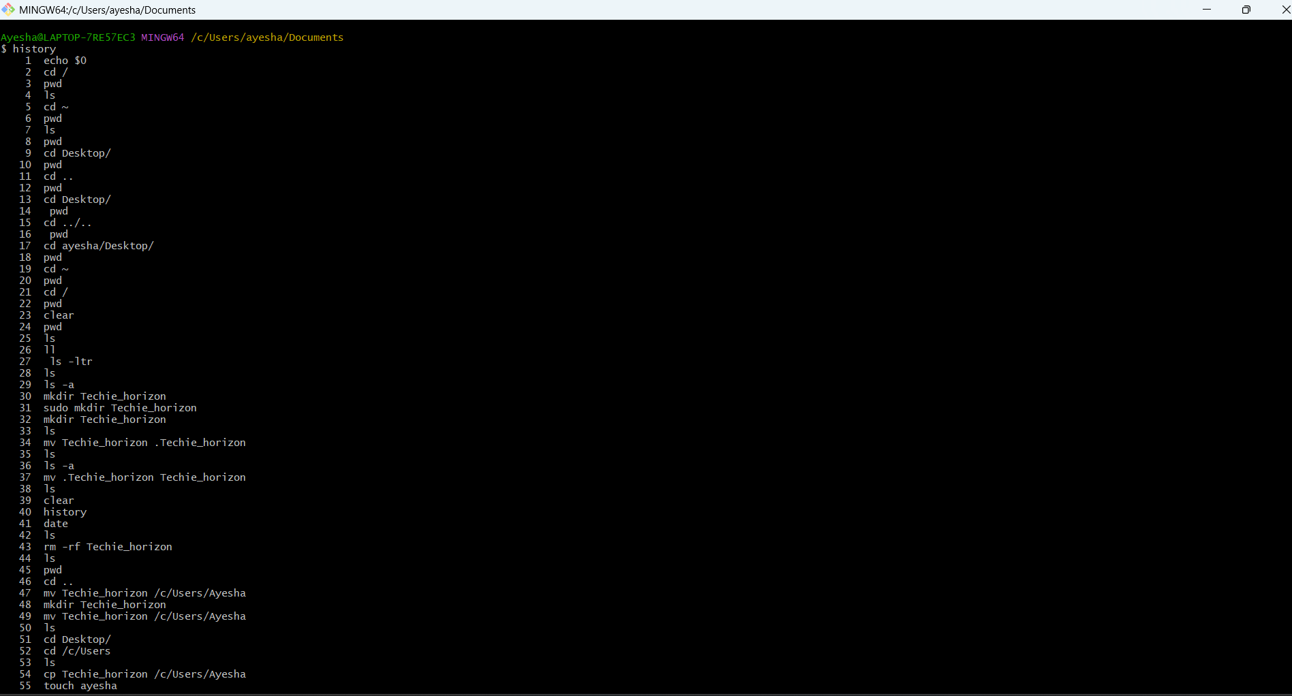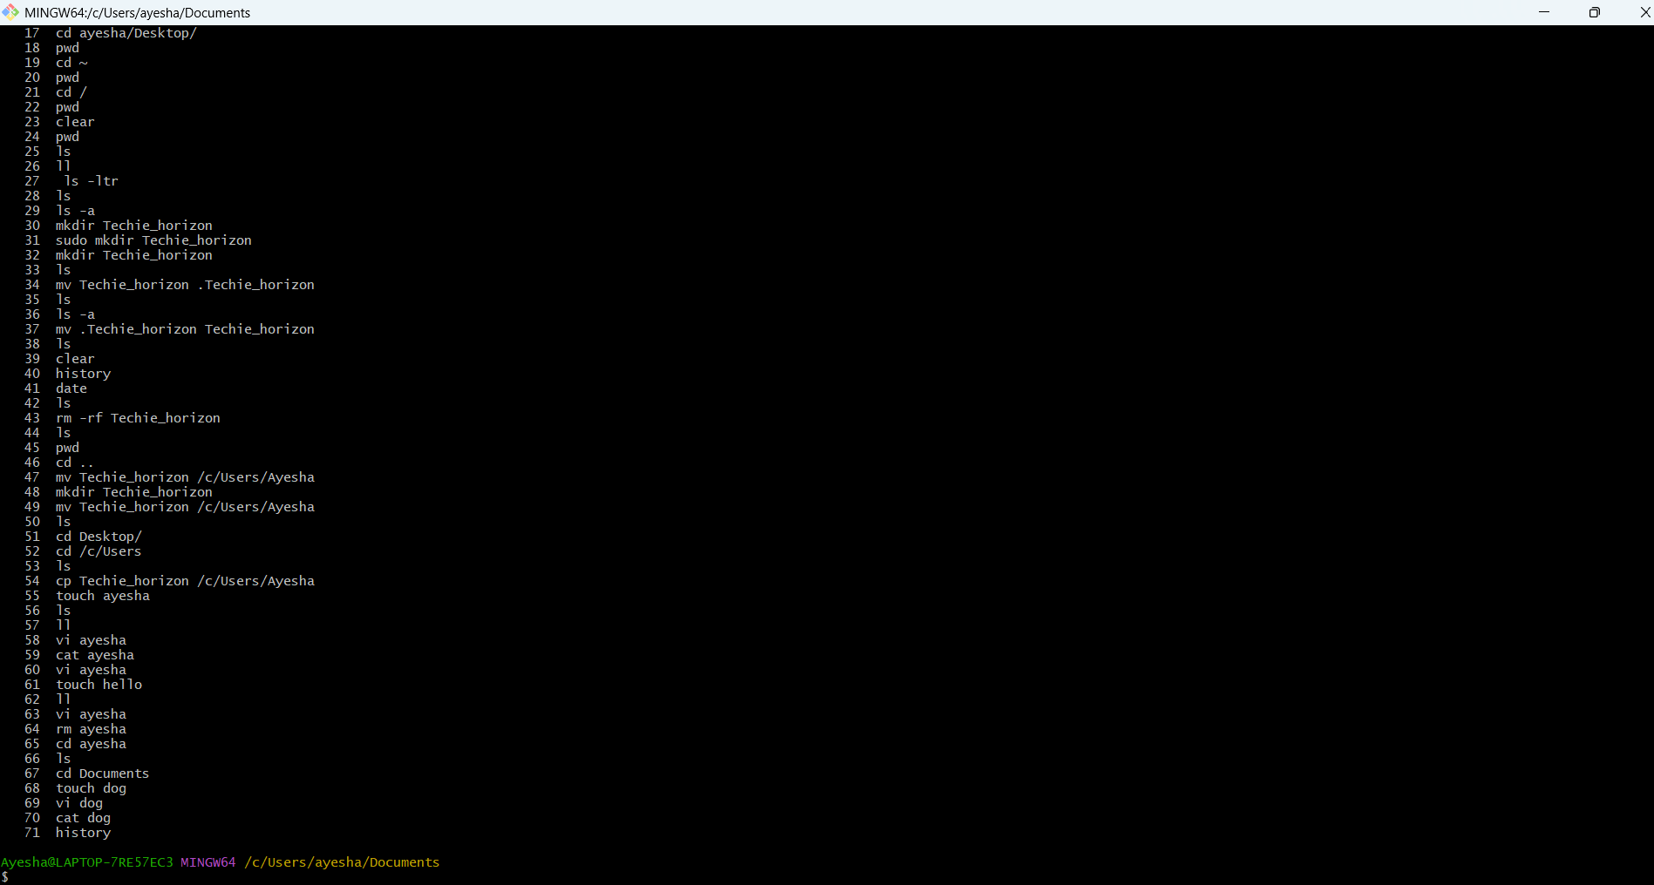

- I used history to view all the commands I previously executed. It helps me keep track of the commands I performed during my task.

